MED D - Explanation of Benefits (EOB)

How to View EOBs in PeopleSafe
Beneficiary Did Not Receive EOB
Beneficiary Requests Duplicate EOB
Beneficiary Disputes EOB
Changes in the Language Setting or Format Code (Accessible Format)
Related Documents

Description: This document provides the steps to follow for common questions the beneficiary may have regarding their Explanation of Benefits (EOB).

How to View EOBs in PeopleSafe

Perform the following to view EOBs in PeopleSafe:
Step | Action
1 | Verify the following:
1 | If the CCR needs to view… | Then…
1 | 2016 to Present EOBs | - Go to the Tools bar in the Main Screen of PeopleSafe.  - Select Find Med D EOB / TF from 6-2020 link.  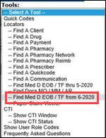  Result: ONEclick window will open.  Refer to Step 3 of Using ONEclick section in MED D - Viewing Correspondence in PeopleSafe work instruction for additional information.
1 | 2015 or prior EOBs | - Go to the Tools bar in the Main Screen of PeopleSafe.  - Select Find Med D EOB / TF thru 5-2020 link.  Exception: For SSI Open only: CCRs will be able to access all EOBs (including 2015 and prior) with the new Medicare D EOB link above.  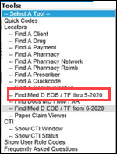

Top of the Document

Beneficiary Did Not Receive EOB

If the beneficiary calls stating they have been enrolled in the MED D plan for several months and has NOT received an EOB, the CCR will follow the steps listed below:
Step | Action
1 | View the beneficiary’s EOB information. Refer to How to View EOBs in PeopleSafe section in this document.  Note: Beneficiaries may be set up to receive an electronic EOB. For more information, see Med D – Electronic EOBs.
1 | If the CCR… | Then…
1 | Has visibility to EOB AND the beneficiary is NOT receiving it  Note: Check the beneficiary account to see if they had any prescription activity during the month in question. If no activity shown, the beneficiary would not have an EOB printed for the month in question. | Verify the beneficiary’s address on file.
1 |  | If the address is… | Then…
1 |  | Correct | Refer to Beneficiary Requests Duplicate EOB section to resend the requested EOB.
1 |  | NOT correct | - Update the beneficiary’s address for future EOBs.  - Refer to MED D - Address Changes and Out of Area (OOA).  - Refer to Beneficiary Requests Duplicate EOB section to resend the requested EOB.
1 | Does NOT have visibility to EOB and the beneficiary is NOT receiving  Note: Check the beneficiary account to see if they had any prescription activity during the month in question. If no activity shown, the beneficiary would not have an EOB printed for the month in question. | Notify client support team via the Form for Reporting Client Issues stating that visibility to beneficiary's EOB is not available. Refer to Submitting Feedback and Reporting Client Issues.

Top of the Document

Beneficiary Requests Duplicate EOB
The beneficiary can call Customer Care and request a duplicate EOB for any month in which one was originally sent.

Often the beneficiary will request an EOB with year-end information.
- In this case the Customer Care Rep will request a duplicate EOB for the last available month with prescription activity
- In the case that the beneficiary requests all 12 EOBs for the previous year, the Customer Care Rep should offer a Statement of Cost for the prior year.
Note: Only those months for which the beneficiary had claim activity will have an EOB available for request

In order to request duplicate EOBs the CCR will following the steps detailed below:
Step | Action
1 | Access OneClick in PeopleSafe. Refer to MED D - Viewing Correspondence and Requesting Reprints in PeopleSafe.
2 | Locate and verify the EOB the beneficiary would like reprinted in the document list.  Note: Review the EOB to confirm it contains the claim dates the beneficiary is requesting.  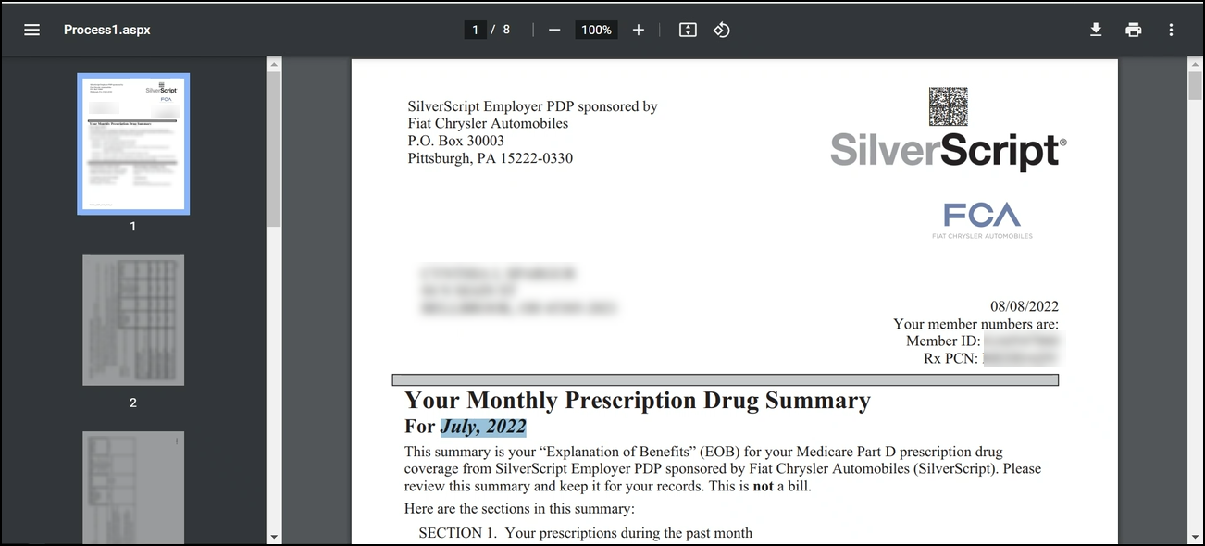
3 | To request a reprint of an existing EOB(s), select the radio button in the Event Code column.  Note: Only one EOB reprint can be selected at a time. If a beneficiary needs multiple EOBs, repeat this process for each EOB.  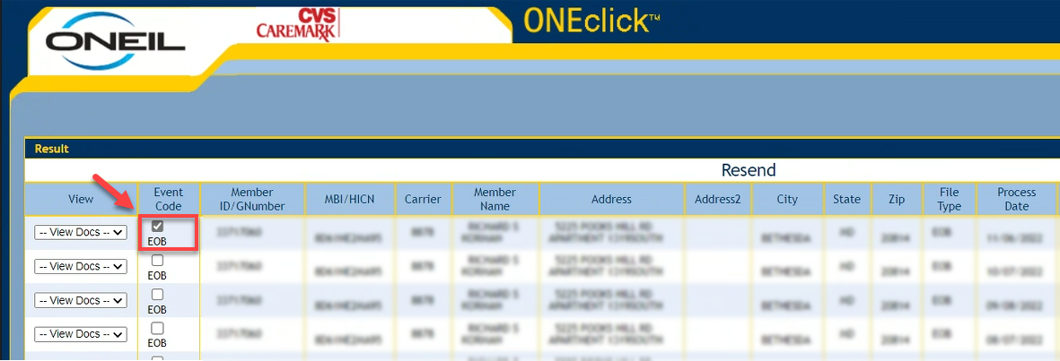
4 | Select Resend.  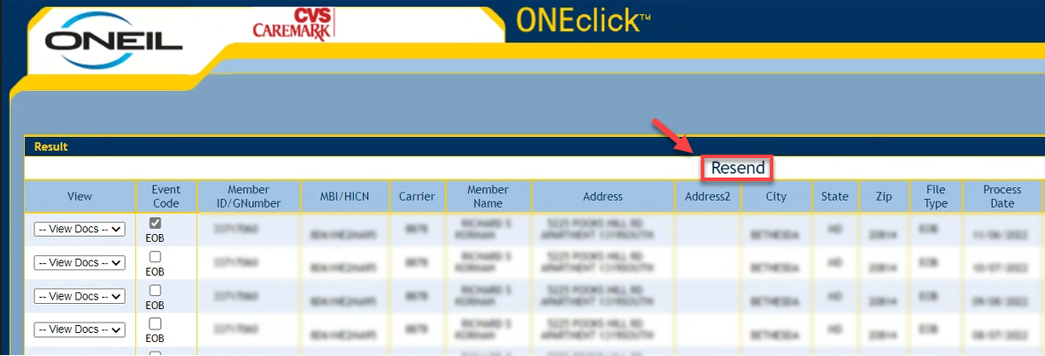
5 | The Confirm Resend Details screen will pop up.  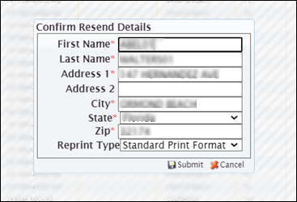
6   | We will request a duplicate copy of the EOB.  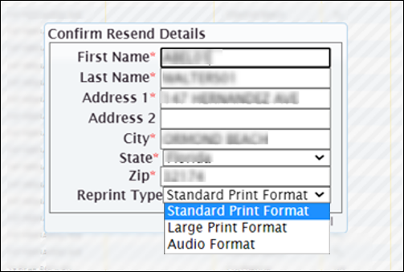  Select Standard Print Format.
7 | Confirm the address the beneficiary would like the EOB reprint mailed to.
7 | If… | Then…
7 | Current address on file | Select Submit to process the reprint.
7 | New address | Is this a temporary address for this EOB reprint only?
7 | New address | If... | Then...
7 | New address | Yes | Update address in Confirm Resend Details screen and click Submit. Document that a one-time address was used for the EOB reprint.  Refer to MED D - Call Documentation Including Viewing and Adding Comments in PeopleSafe.
7 | New address | No | Update address in Confirm Resend Details screen and click Submit and update the address, as appropriate, in PeopleSafe.  Refer to MED D - Address Changes and Out of Area (OOA).
8 | Explain next steps.  You should receive the requested version of your EOB within 20 business days.

Top of the Document

Beneficiary Disputes EOB

If the beneficiary calls and is disputing the information on the EOB, perform the steps below:
Step | Action
1 | Review Claim History screen for disputed medications.
1 | If claim... | Then...
1 | Is active and showing paid | - Ask probing questions to determine the reason for the dispute.  - Ask the beneficiary if they contacted the pharmacy; prescriber may have ordered the medication.  - Ask the beneficiary if the medication was ordered but they chose to not pick it up; pharmacy may need to be contacted to reverse the claim.  - Follow appropriate work instruction to address the issue.
1 | Was reversed | Advise the caller the claims were showing as paid at the time that the report was run to generate the EOB, however they have since been reversed and will reflect on their next EOB.

Top of the Document

Changes in the Language Setting or Format Code (Accessible Format)
Refer to MED D - Fulfillment Request.

Top of the Document

Related Documents
- Grievance Standard Verbiage (for use in Discussion with Beneficiary) section in MED D - Grievances Index
- MED D - Explanation of Benefits (EOB) General Information

Parent SOP: CALL-0048: Medicare Part D Customer Care Call Center Requirements-CVS Caremark Part D Services, L.L.C.
Abbreviations/Definitions: Abbreviations / Definitions

Top of the Document

Not to Be Reproduced or Disclosed to Others without Prior Written Approval
ELECTRONIC DATA = OFFICIAL VERSION - PAPER COPY = INFORMATIONAL ONLY

